

**CSE302: Database Systems (Section 2)**

**[FALL 2022]**

**Project Report**

Fifa World Cup 2022

https://apex.oracle.com/pls/apex/r/2020160189/fifa-world-cup-2022/

**Submitted by:**

| **Student ID** | **Student Name** | **Contribution Percentage** |
| --- | --- | --- |
| **2020 - 1 - 60 - 189** | **Noushin Pervez** | **29%** |
| **2020 - 2 - 60 - 010** | **Nisarga Mridha** | **29%** |
| **2020 - 2 - 60 - 095** | **Ashraful Islam** | **19%** |
| **2020 - 1 - 60 - 259** | **Rudra Banik** | **23%** |

# Final version of the E-R Model of the Project

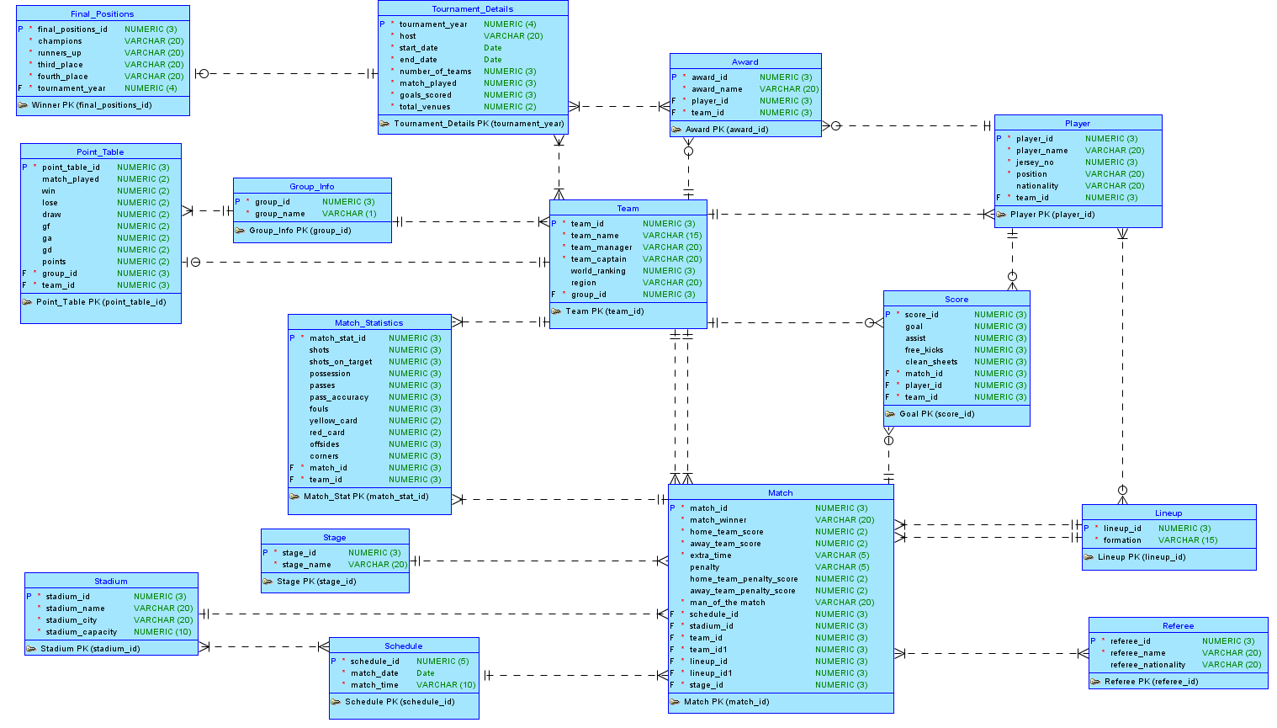

# Final Version of the Relational Data Model of the Project

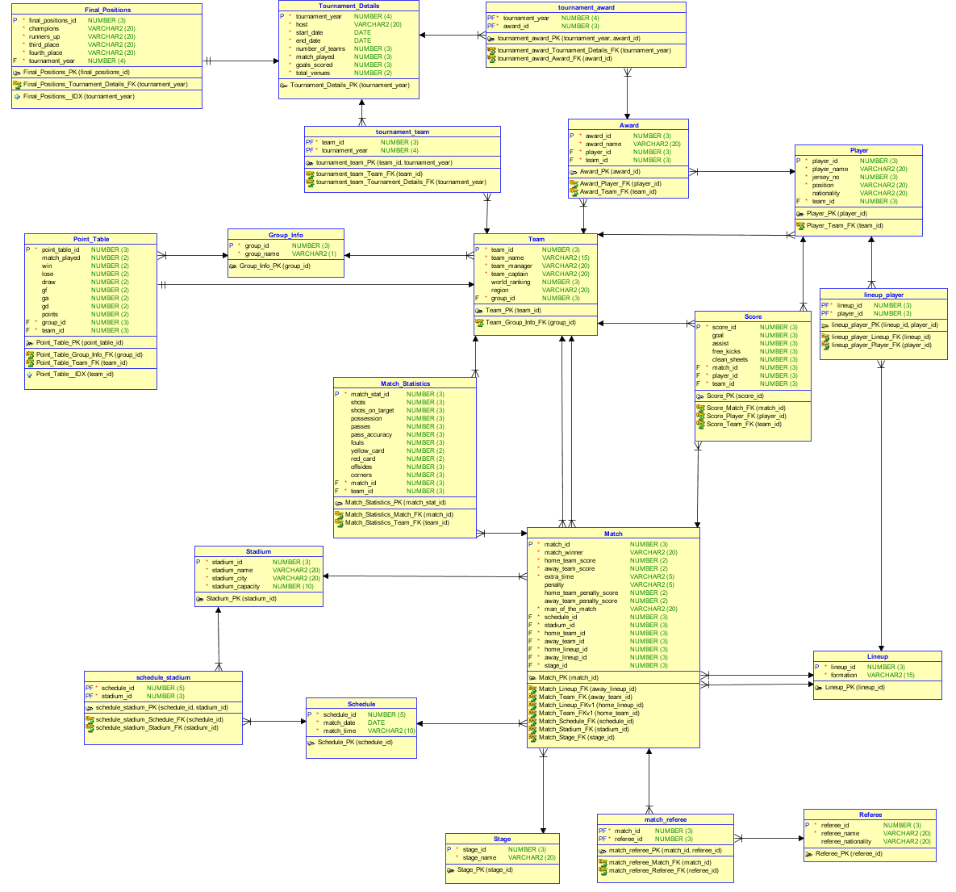

# Implementation Checklist

| Description | Remarks |
| --- | --- |
| Project ID | Application 15950 |
| Workspace Name | 2020160189 |
| Workspace Email | 2020-1-60-189@std.ewubd.edu |
| Workspace Password | cse302group5 |
|  |  |
| Authentication Type | Custom |
| Username and Password to Login | admin |
| write username like admin | admin |
| if you have multiple users, write all username and password correctly | Username: nisarga  Password: nisarga  Username: rudra  Password: rudra  Username: ashraful  Password: ashraful |
| Uploaded and Displayed Images in Reports | yes |
| Implemented Page-wise Authorization | yes |
| Number of Reports with Forms | 17 |
| Number of Master-detail Forms | 3 |
| Number of Reports based on Queries, Aggregate Queries | 7 |
| Number of Parameterized Reports | 5 |
| Number of Graphs/Charts | 2 |
| Included any trigger/other feature which is not taught in class. If yes, please explain briefly. | We used a dashboard report in the first page (Home). For doing this, we had to use an HTML class and some aggregate queries (though aggregate queries have been taught in class). |
| Write the most unique feature/functionality in your application or the page of your application that you are proud of. Explain briefly. | Our application provides a user-friendly interface to retrieve data easily for general users. |

# Reports with Forms

| Report Page Number and Name | Form Page Number and Name | Table |
| --- | --- | --- |
|  | Page 34: Group Input | Group_Info |
| Page 71: Teams Report | Page 11: Team Input | Team |
| Page 8: Players Report | Page 12: Player Input | Player |
|  | Page 13: Stage Input | Stage |
| Page 48: Stadium Report | Page 14: Stadium Input | Stadium |
|  | Page 15: Schedule Input | Schedule |
|  | Page 16: Referee Input | Referee |
|  | Page 17: Lineups Input | Lineup |
|  | Page 18: Match Input | Match |
|  | Page 19: Award Input | Award |
|  | Page 20: Final Positions Input | Final_Positions |
|  | Page 21: Match Statistics Input | Match_Statistics |
|  | Page 22: Points Table Input | Point_Table |
|  | Page 40: Score Input | Score |
|  | Page 47: Match Referee Input | Match_Referee |

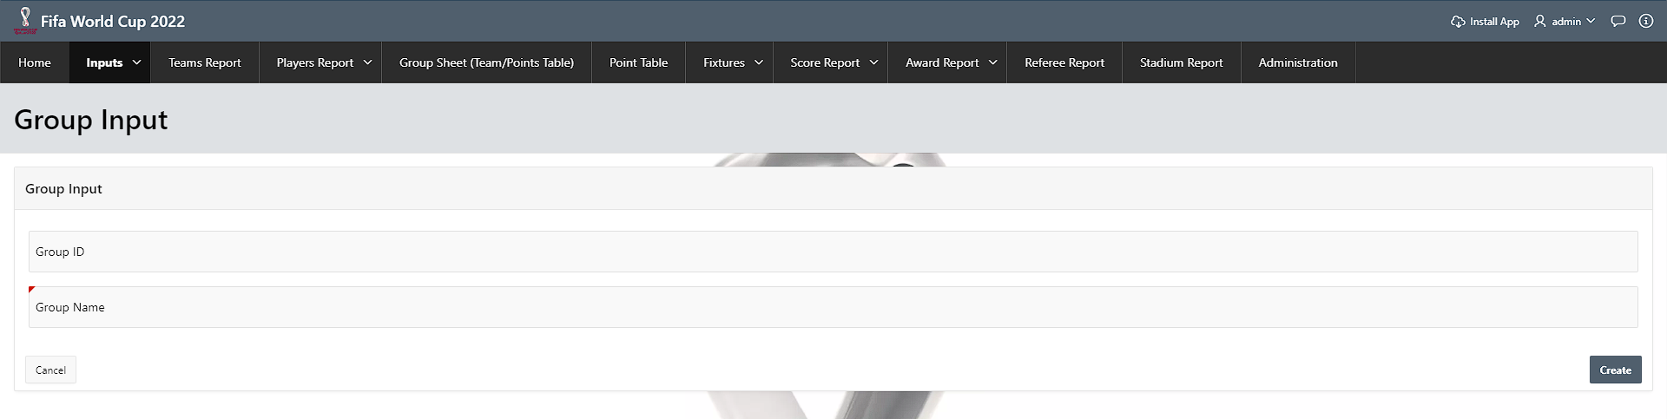

*figure 4.1. Form (Group Input)*

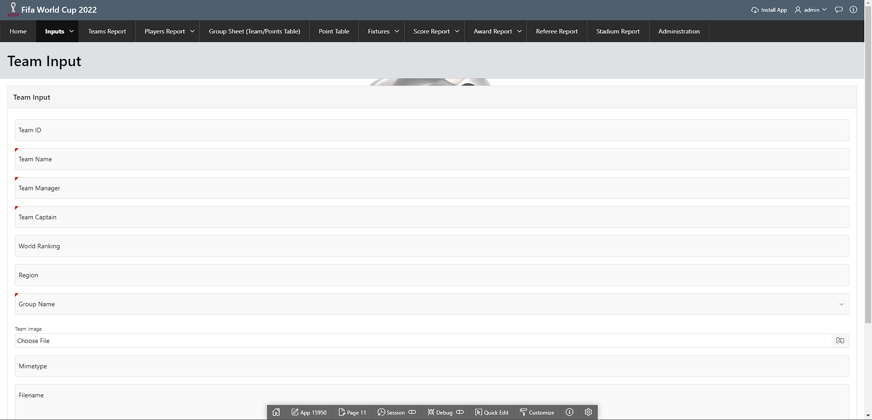

*figure 4.2. Form (Team Input)*

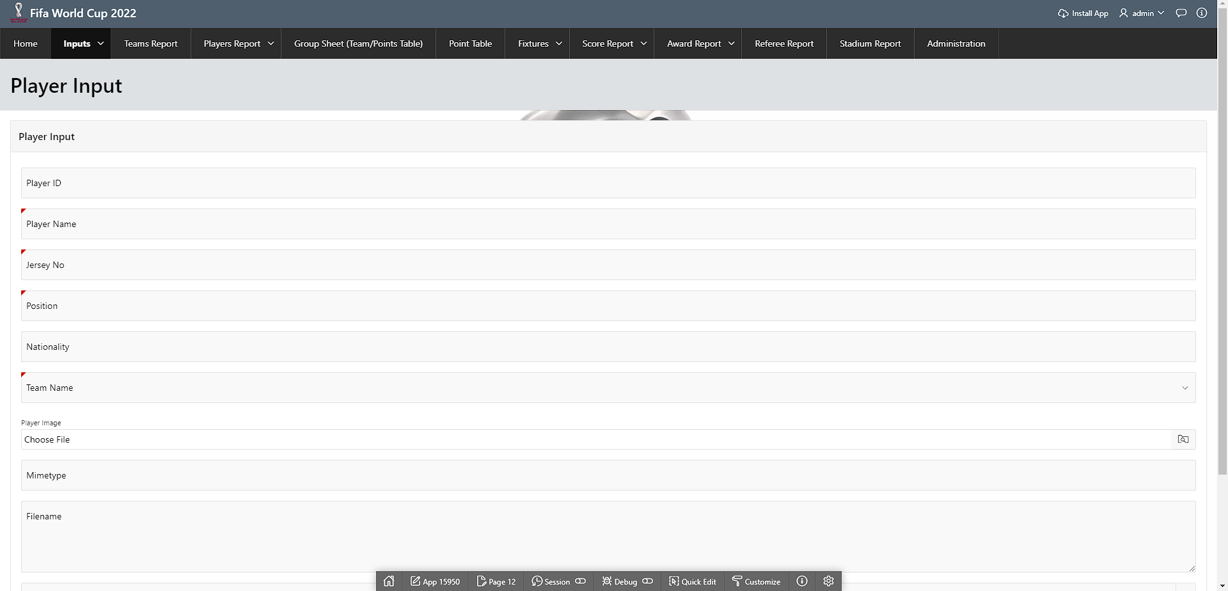

*figure 4.3. Form (Player Input)*

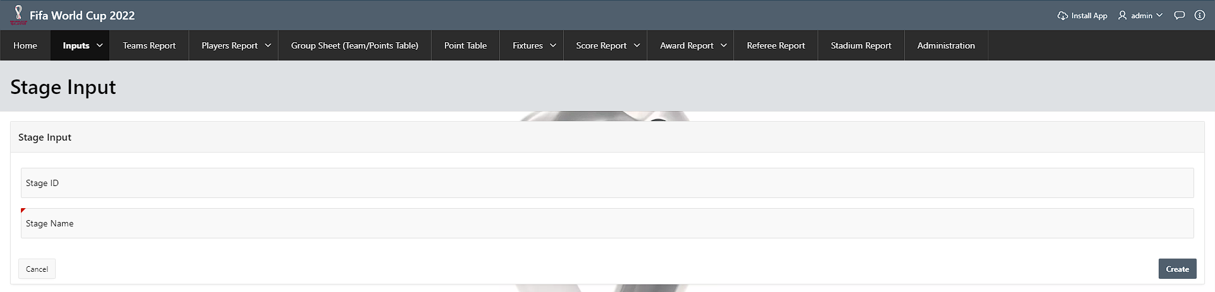

*figure 4.4. Form (Stage Input)*

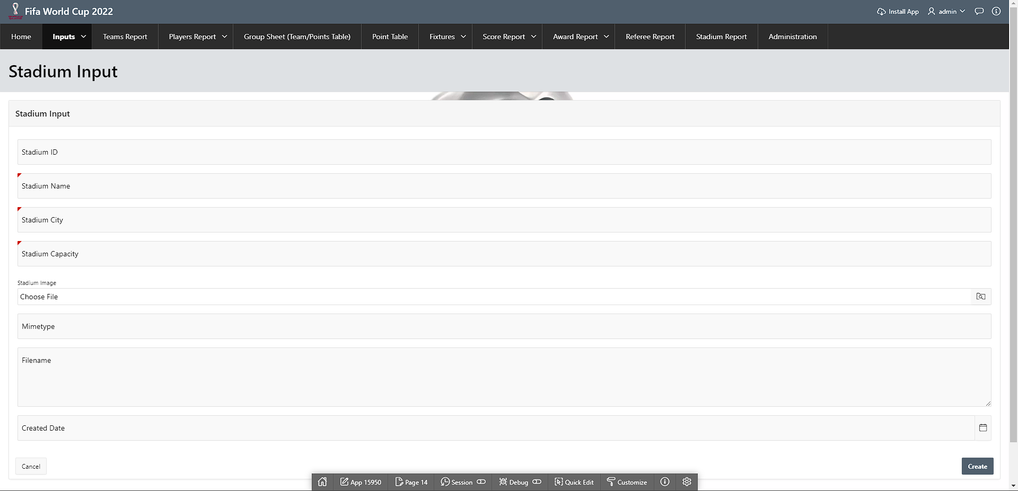

*figure 4.5. Form (Stadium Input)*

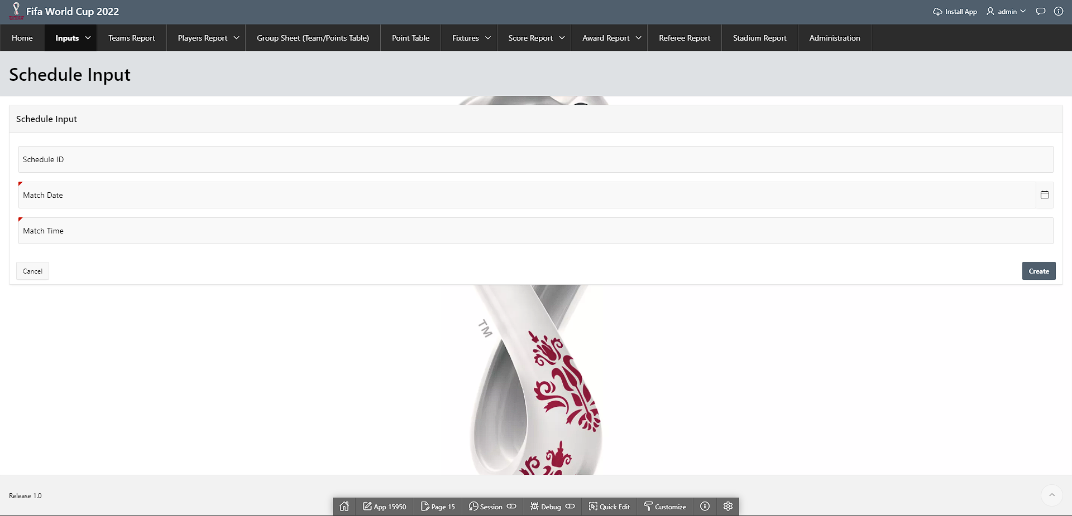

*figure 4.6. Form (Schedule Input)*

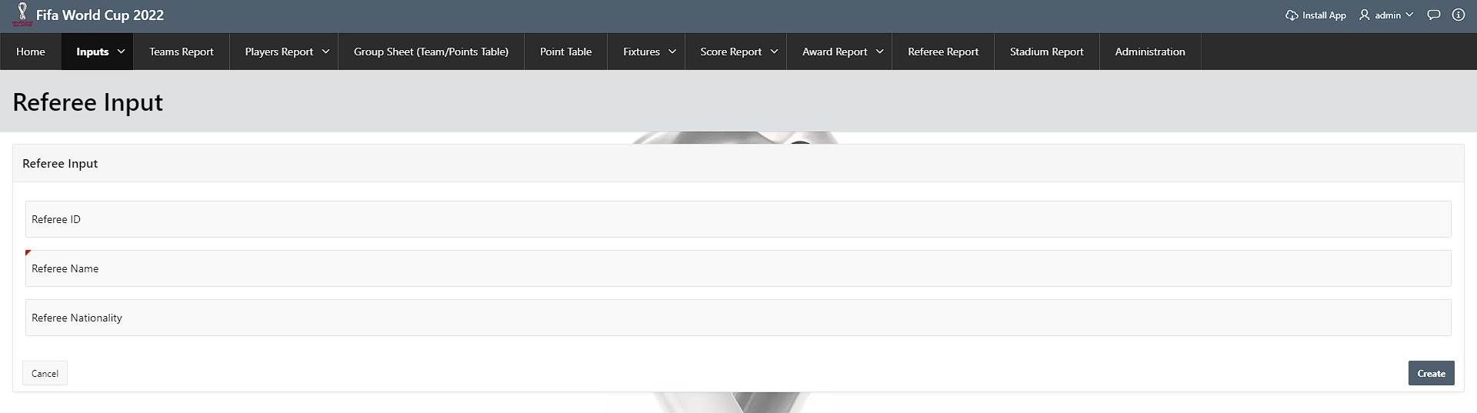

*figure 4.7. Form (Referee Input)*

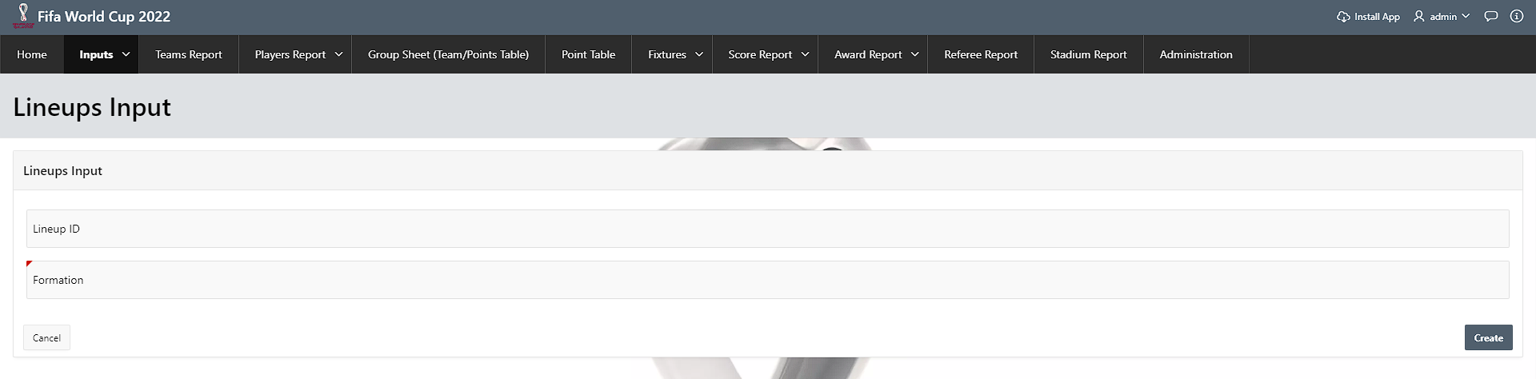

*figure 4.8. Form (Lineups Input)*

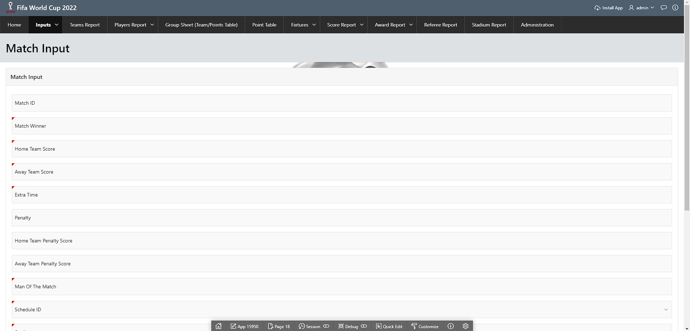

*figure 4.9. Form (Match Input)*

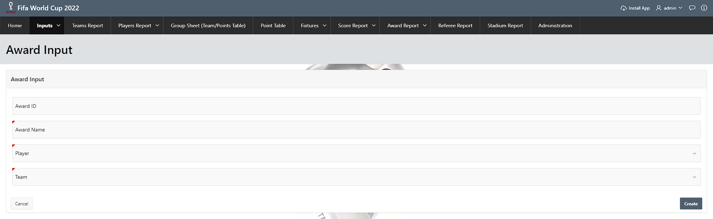

*figure 4.10. Form (Award Input)*

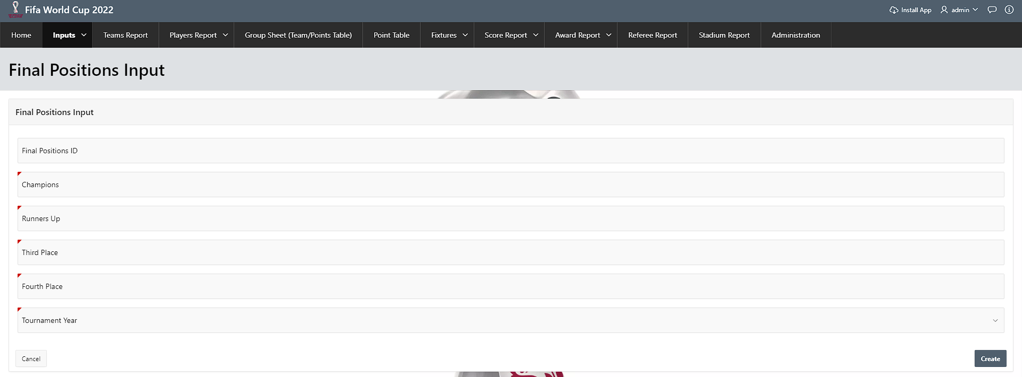

*figure 4.11. Form (Final Position Input)*

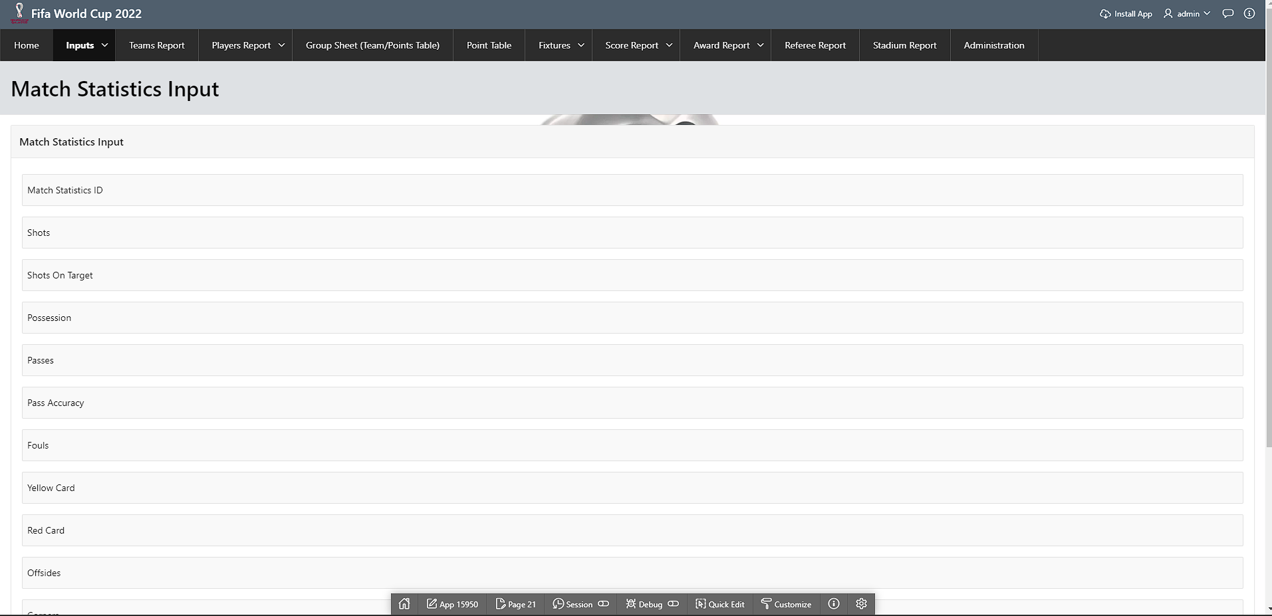

*figure 4.12. Form (Match Statistics Input)*

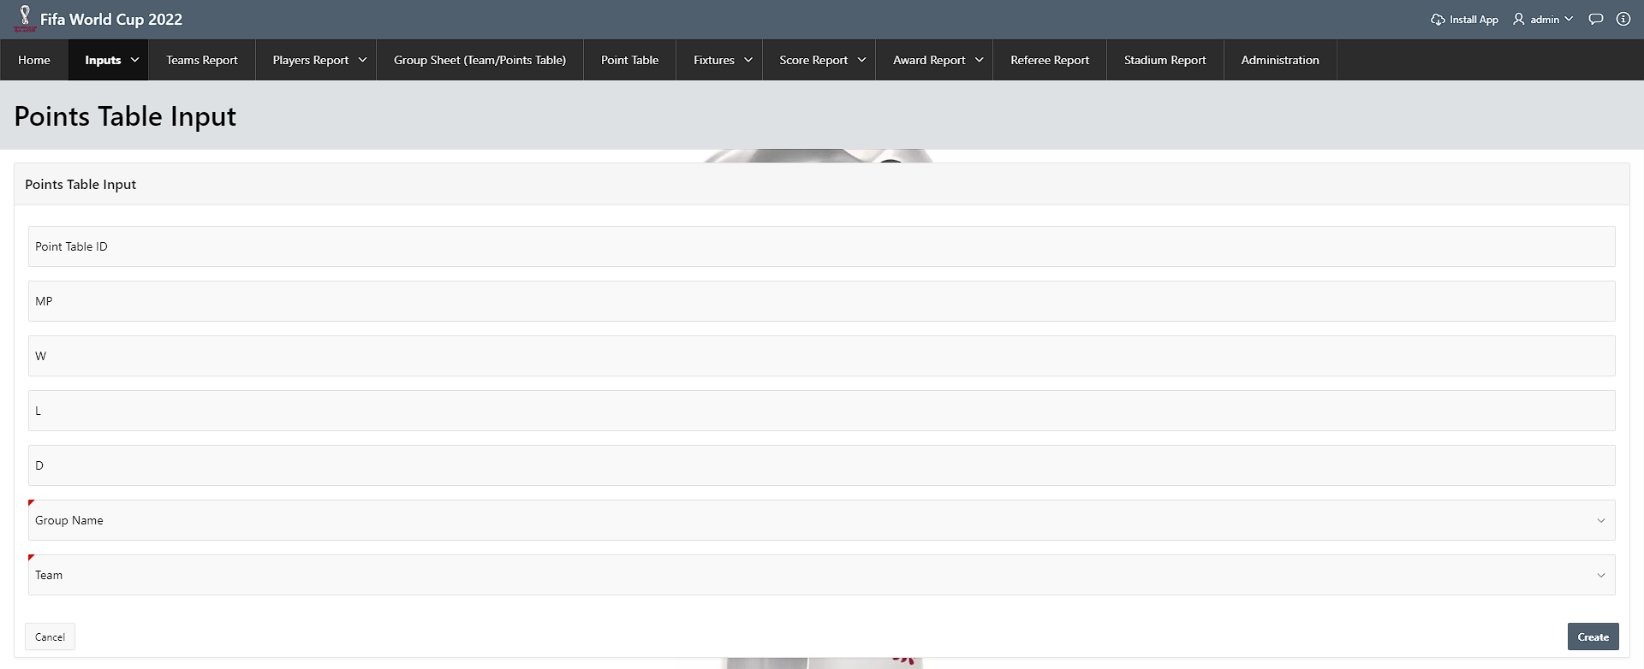

*figure 4.13. Form (Points Table Input)*

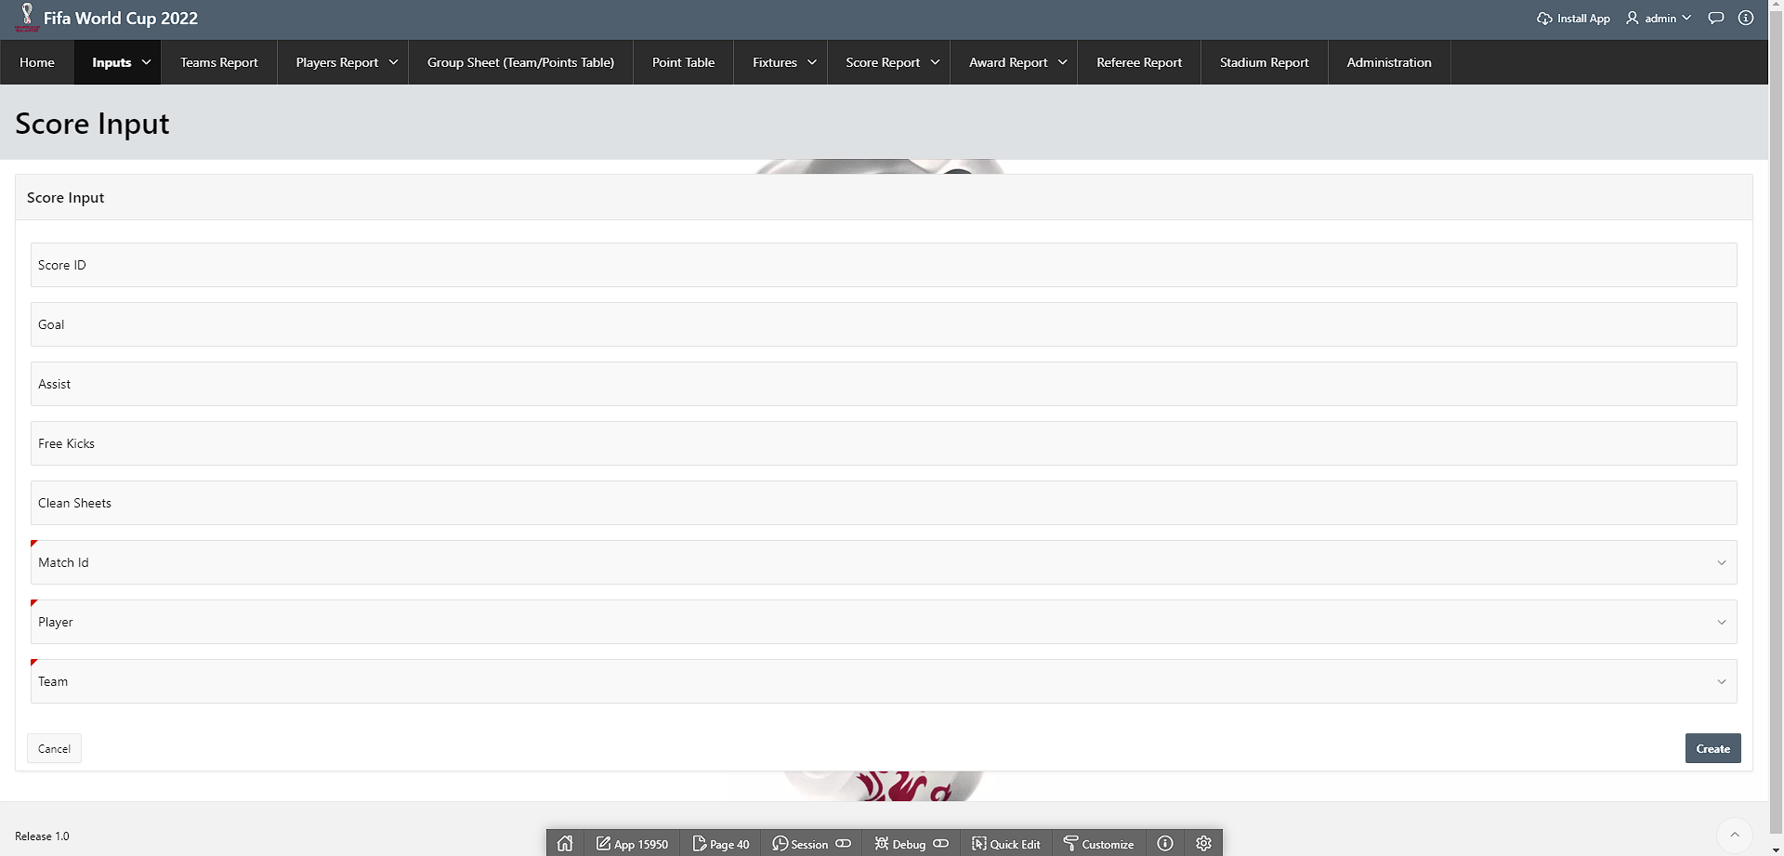

*figure 4.14. Form (Score Input)*

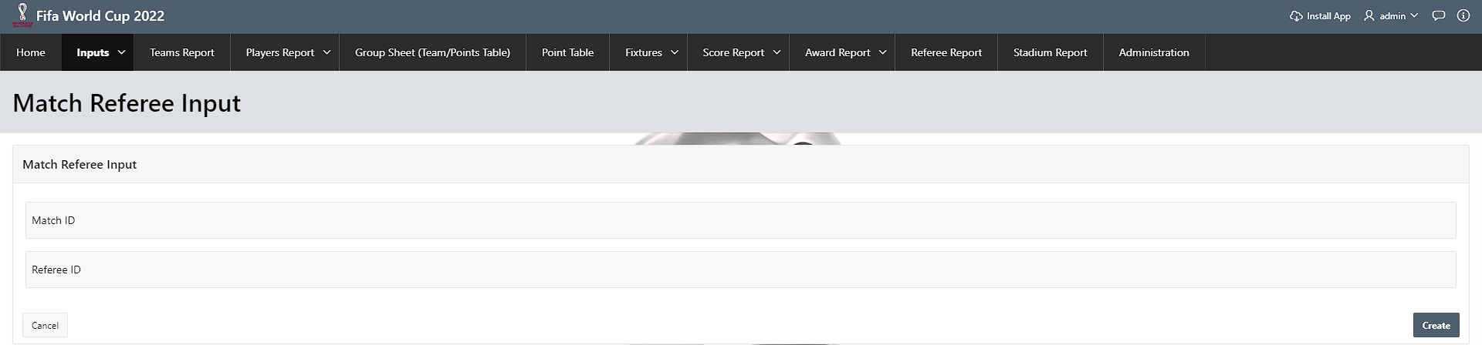

*figure 4.15. Form (Match Referee Input)*

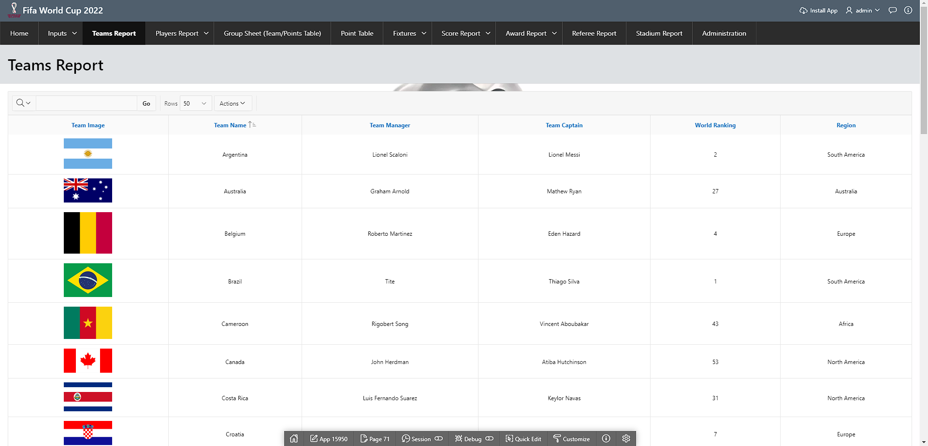

*figure 4.16. Report (Teams Report)*

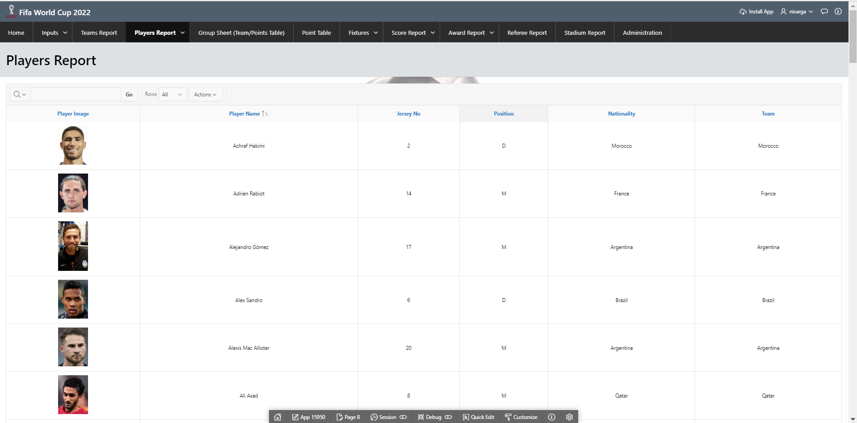

*figure 4.17. Report (Players Report)*

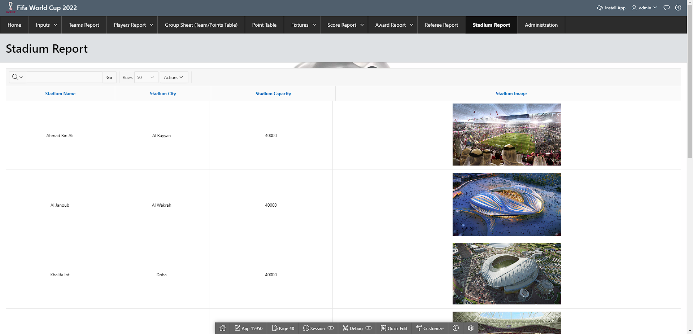

*figure 4.18. Report (Stadium Report)*

# Master-Detail Form

| Page Number and Name | Master Table (Parent) | Detail Table (Child) |
| --- | --- | --- |
| Page 36: Players Information | Team | Player |
| Page 130: Group Sheet (Team/Points Table) | Group_Info | Team, Point_Table |
| Page 123: Match Information | Match | Match_Statistics, Score, Match_Referee |

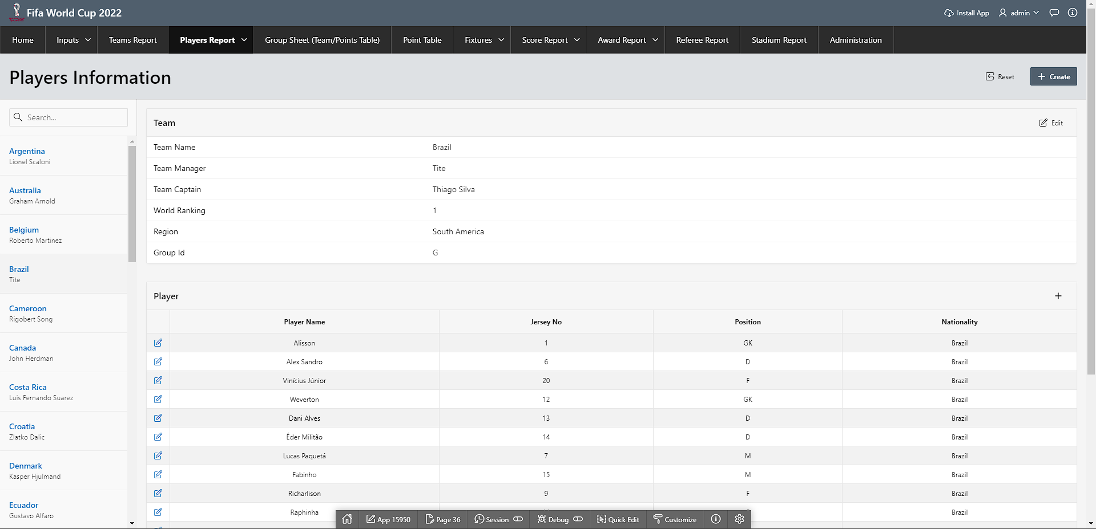

*figure 5.1. Master-Detail Form (Players Information)*

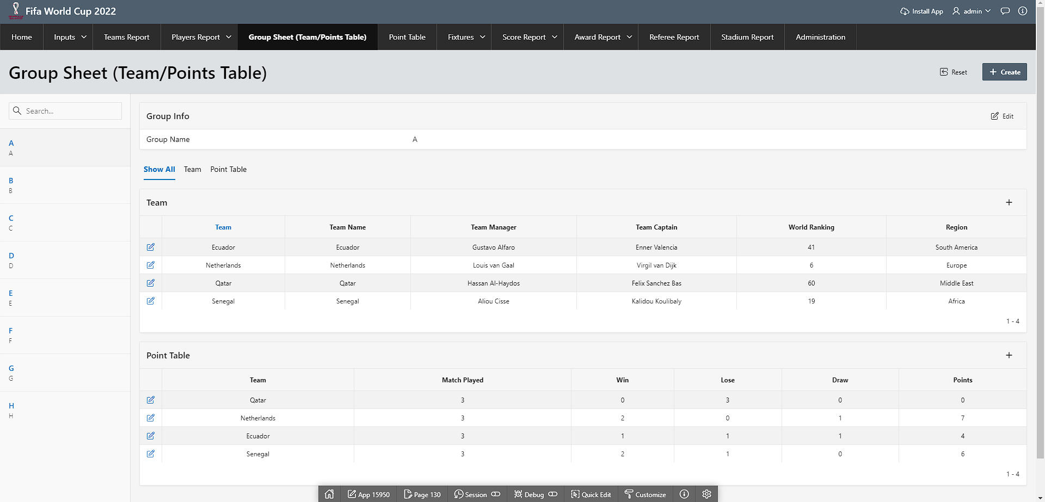

*figure 5.2. Master-Detail Form (Group Sheet (Team/Point Table))*

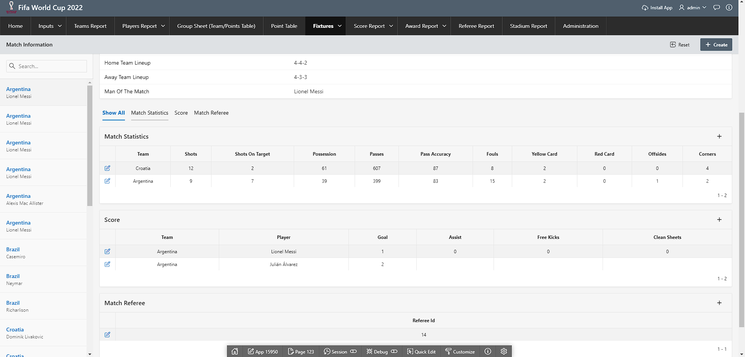

*figure 5.3. Master-Detail Form (Match Information)*

# Reports based on Multi-Table and Aggregate Queries

| Page Number and Name | Query Type | Report description |
| --- | --- | --- |
| Page 1: Home | Aggregate Queries | This shows a dashboard of the tournament. We used aggregate queries for total_stadiums, total_referee, total_matches, total_teams, total_players |
| Page 10: Point Table | Aggregate | This report shows the points table and calculates the points using aggregate for each team |
| Page 98: Fixtures | Multi-table | This report shows the fixtures information depending on stage_name and stadium_name from search |
| Page 27: Score Report | Aggregate | This shows the sum of goals, assists, clean sheets and free kicks for each player from different matches |
| Page 28: Golden Boot | Aggregate | This shows the top 5 player candidates of golden boot |
| Page 93: Golden Ball | Aggregate | This shows the top 5 player candidates of golden ball |
| Page 43: Referee Report | Multi-table | This shows the information of referees assigned to each match |
| Page 95: Players Performance | Aggregate | This shows a chart of sum of goals |
| Page 96: Players Overall Performance | Aggregate | This shows a chart of players sum of goals and |

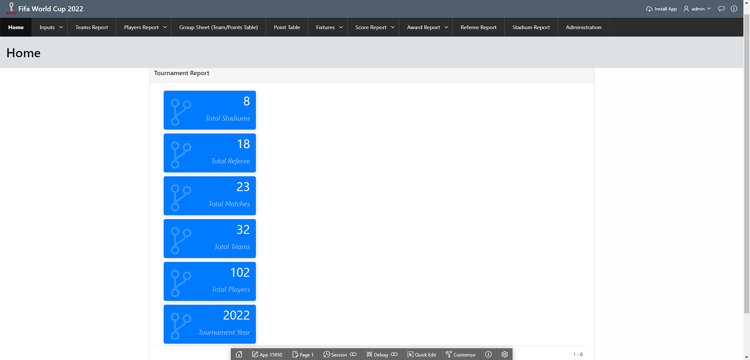

*figure 6.1. Report Based on Aggregate Queries (Home)*

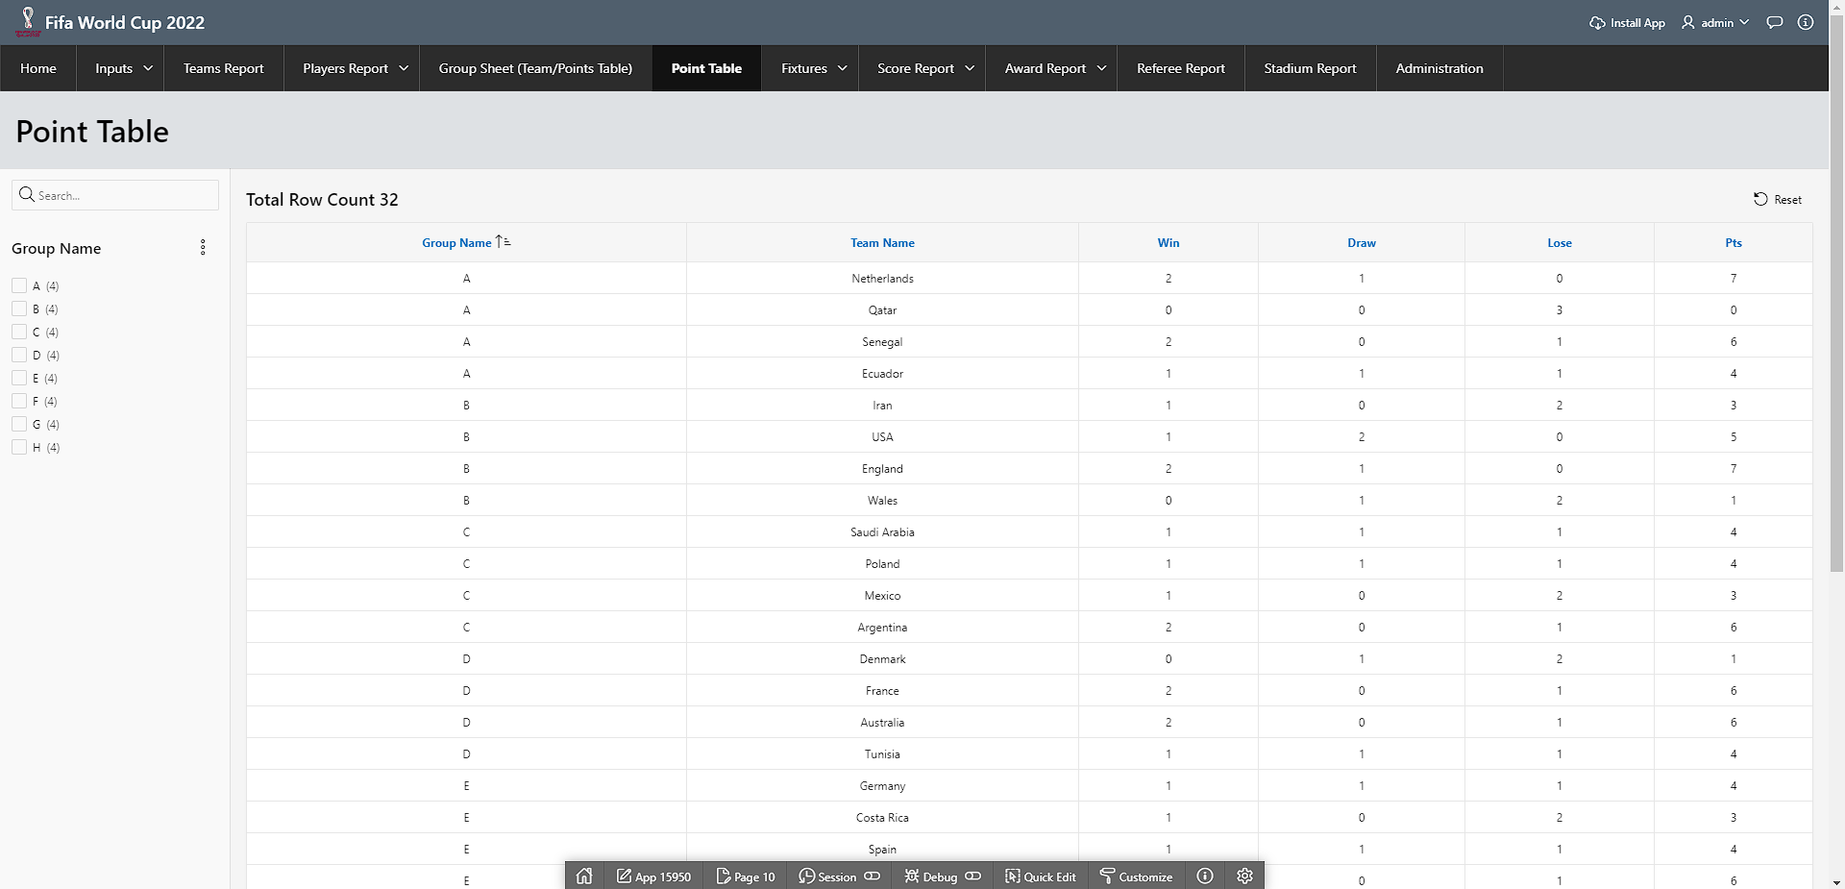

*figure 6.2. Report Based on Aggregate Queries (Point Table)*

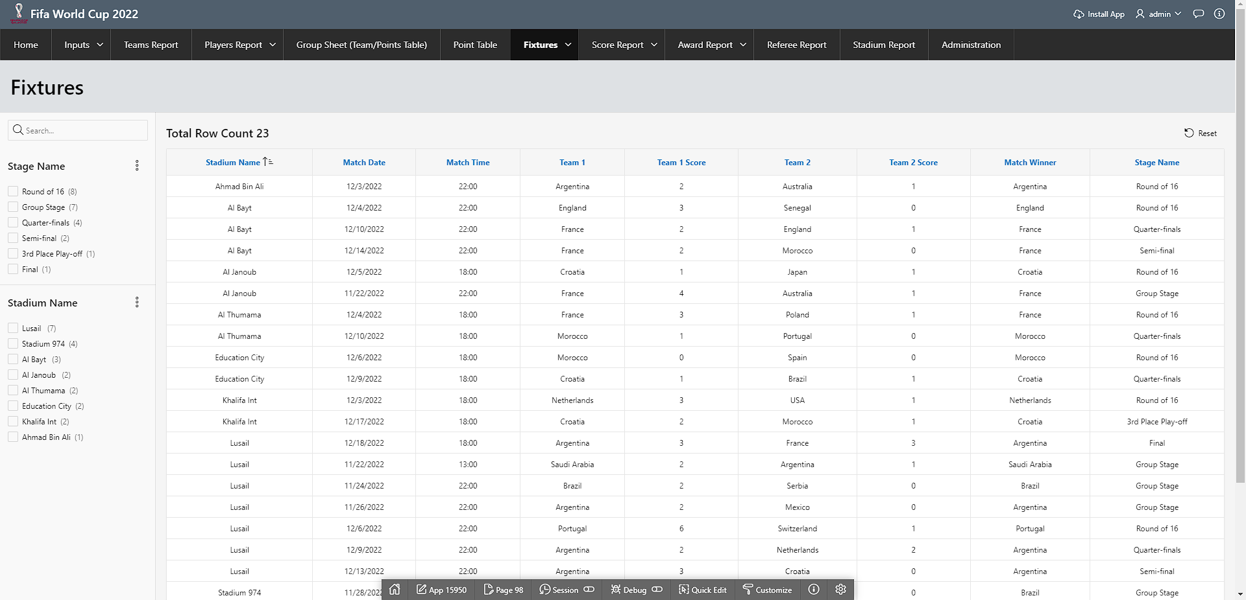

*figure 6.3. Report Based on Multi-Table (Fixtures)*

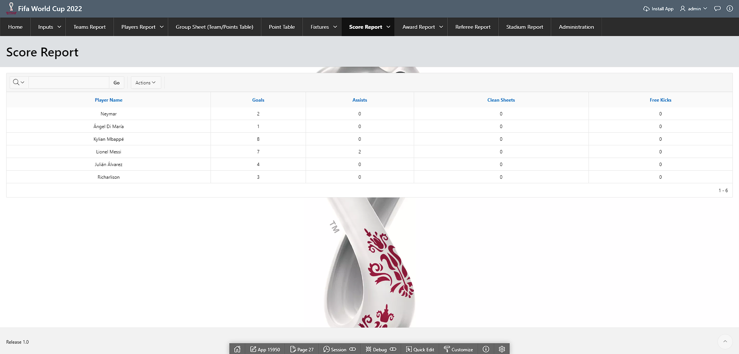

*figure 6.4. Report Based on Aggregate Queries (Score Report)*

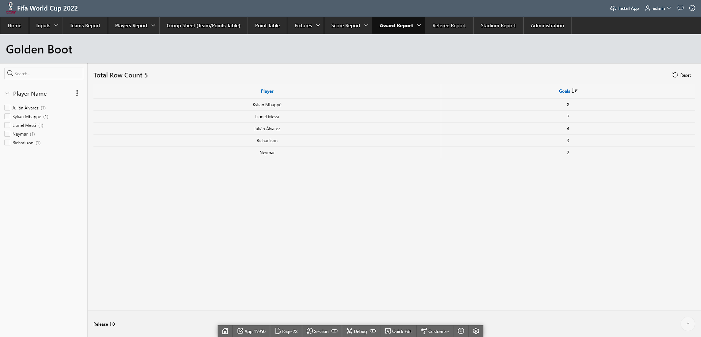

*figure 6.5. Report Based on Aggregate Queries (Golden Boot)*

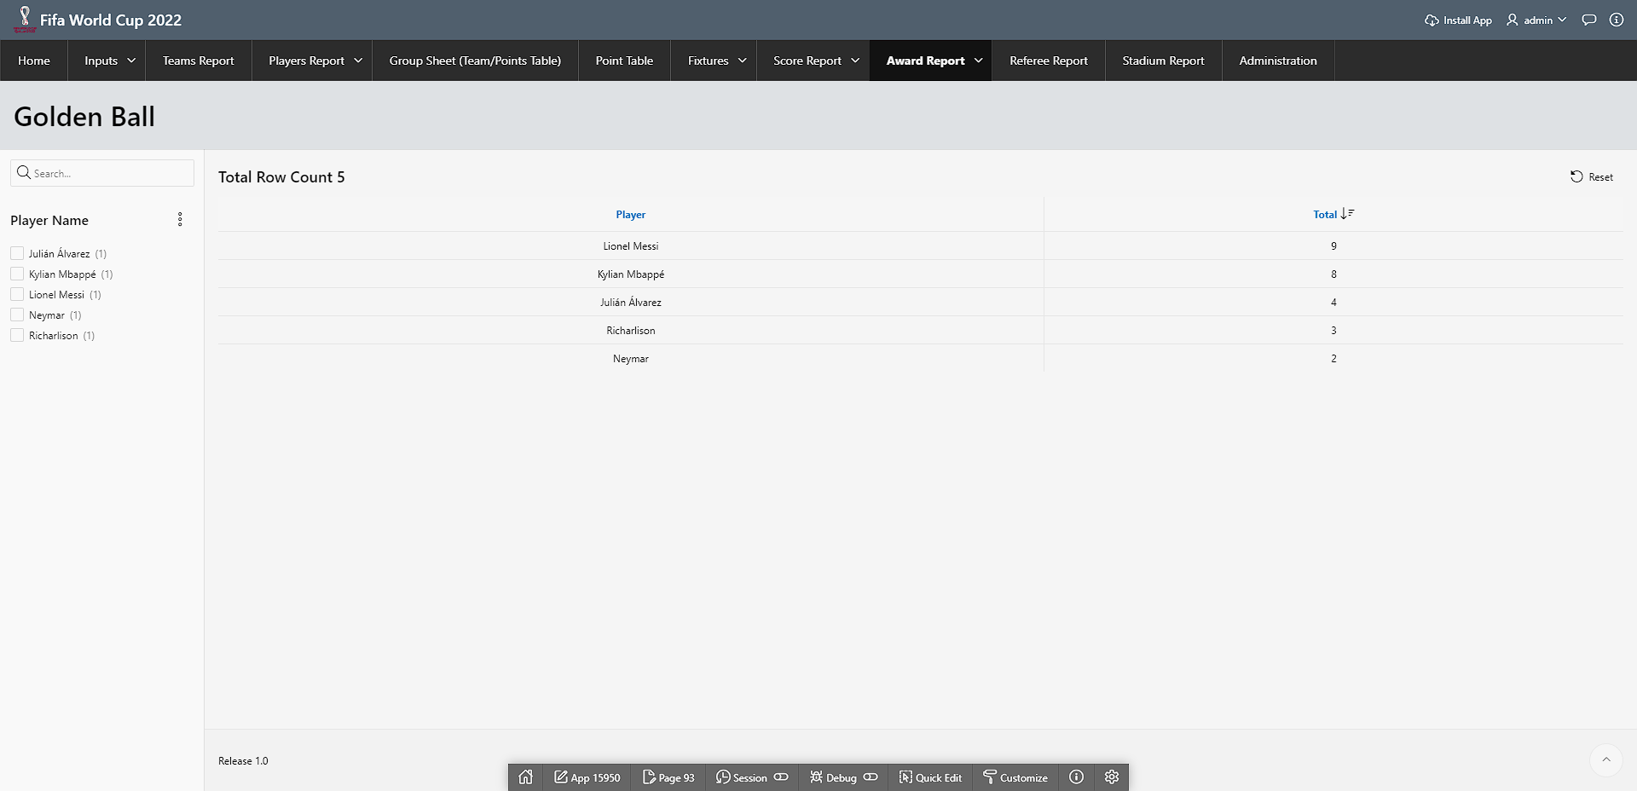

*figure 6.6. Report Based on Aggregate Queries (Golden Ball)*

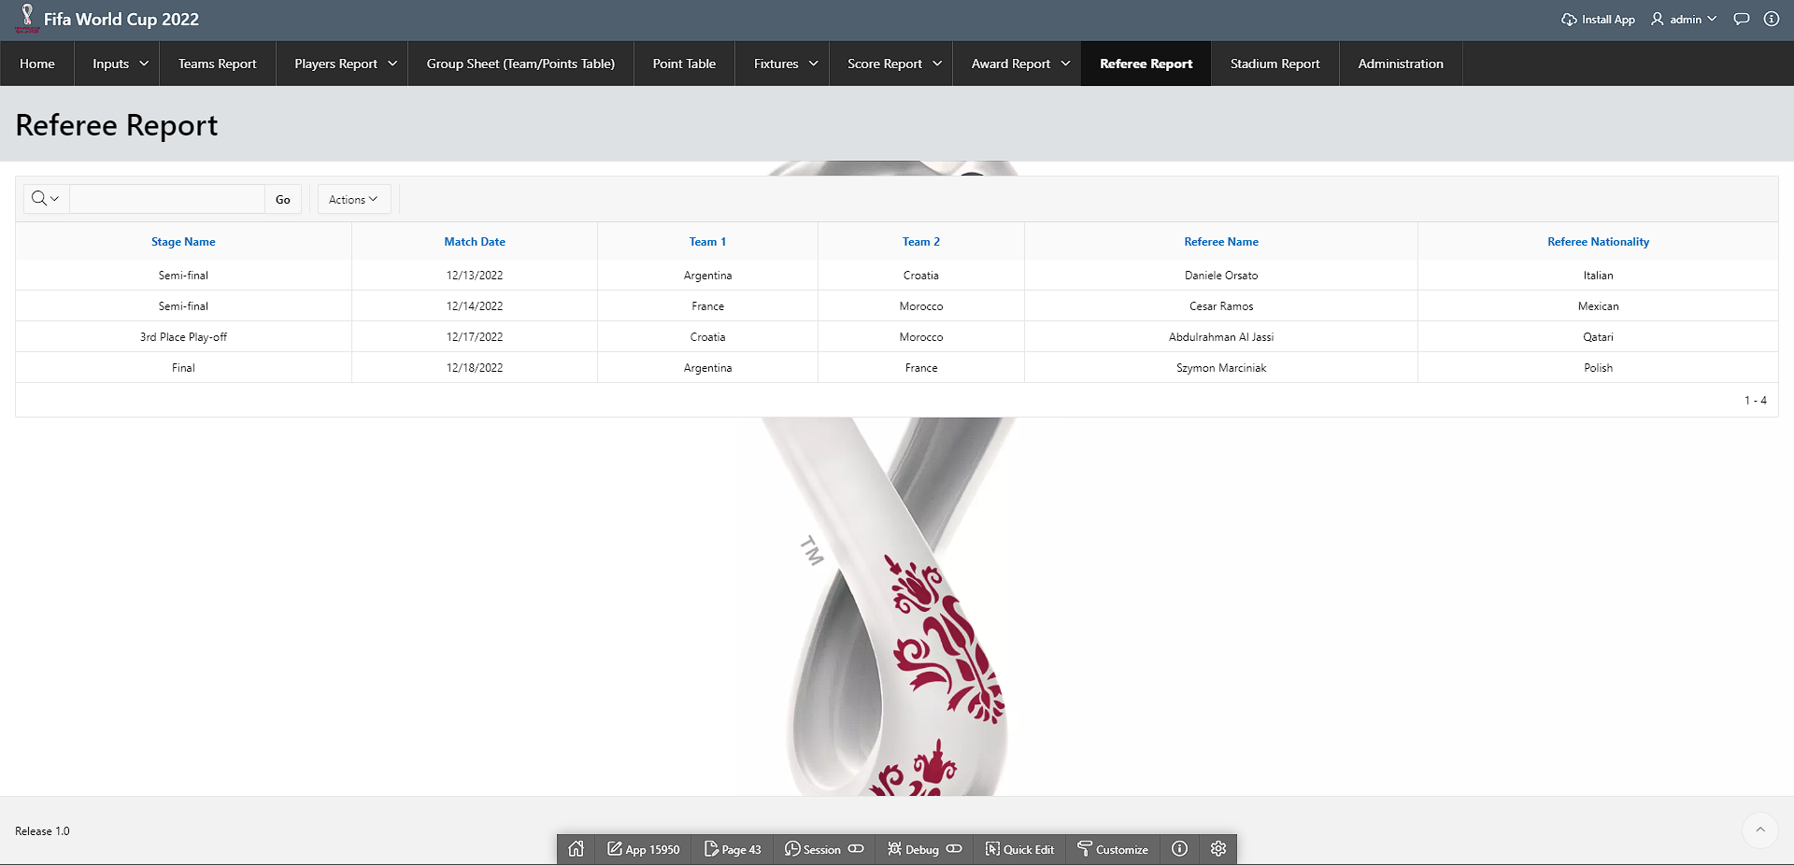

*figure 6.7. Report Based on Multi-Table (Referee Report)*

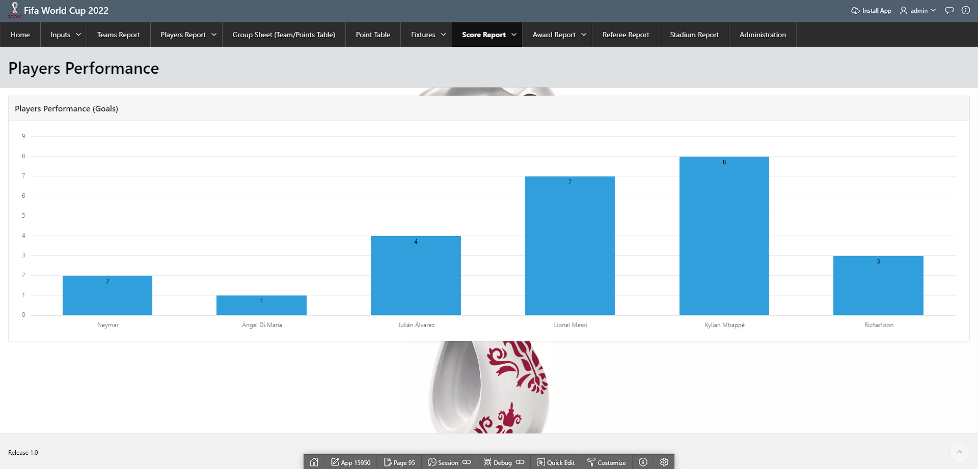

*figure 6.8. Report Based on Aggregate Queries (Player Performance)*

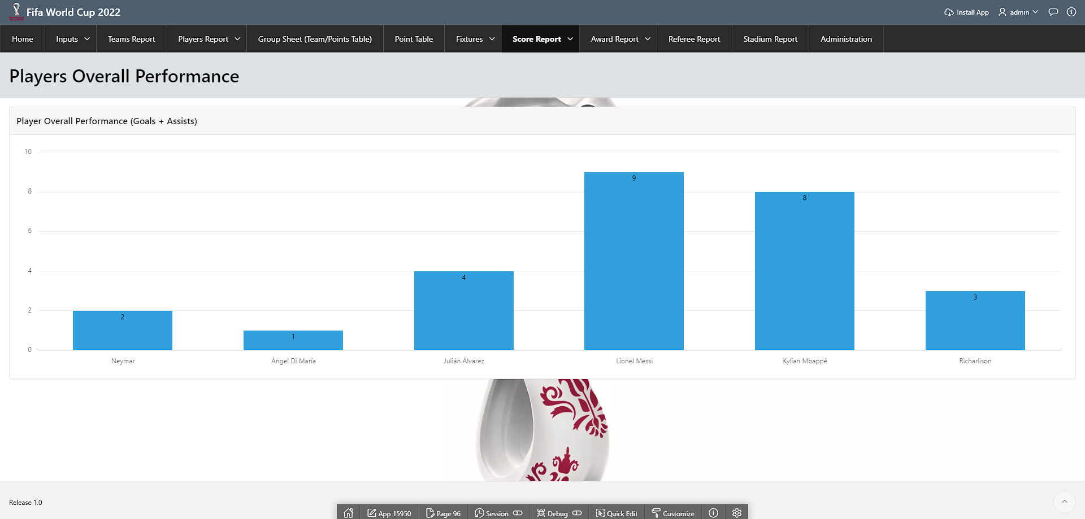

*figure 6.9. Report Based on Aggregate Queries (Player Overall Performance)*

# Parameterized Reports

| Page Number and Name | Given Input | Report description |
| --- | --- | --- |
| Page 10: Point Table | Group name | This report shows the points table information for each group |
| Page 98: Fixtures | Stage Name, Stadium Name | This report shows the fixtures for each stage name and stadium name |
| Page 4: Match Filters | Match Winner, Man of the Match, Penalty, Extra Time, Match Date | This report shows the fixtures for given search |
| Page 28: Golden Boot | Player Name | This report shows the top 5 player candidates of golden boot |
| Page 93: Golden Ball | Player Name | This report shows the top 5 player candidates of golden ball |

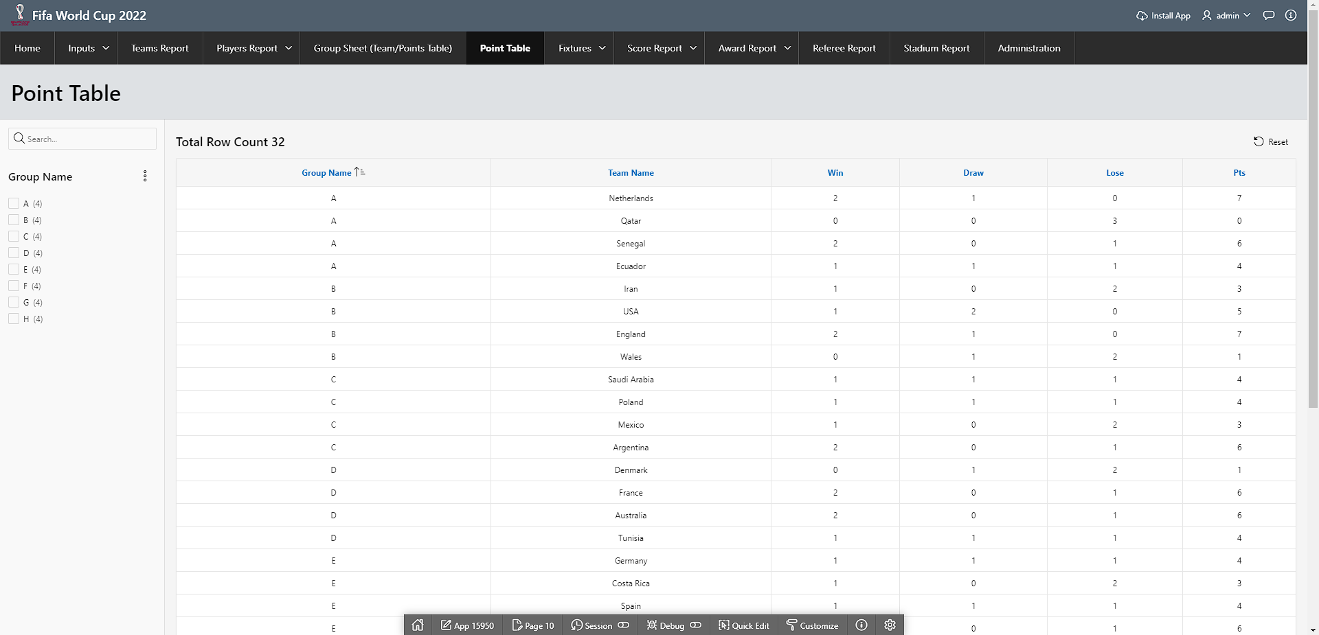

*figure 7.1. Parameterized Reports (Point Table)*

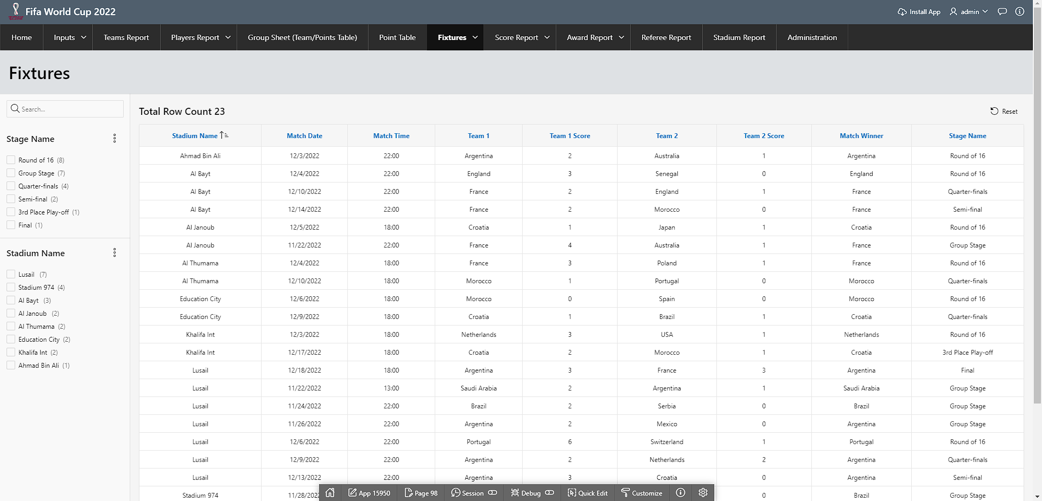

*figure 7.2. Parameterized Reports (Fixtures)*

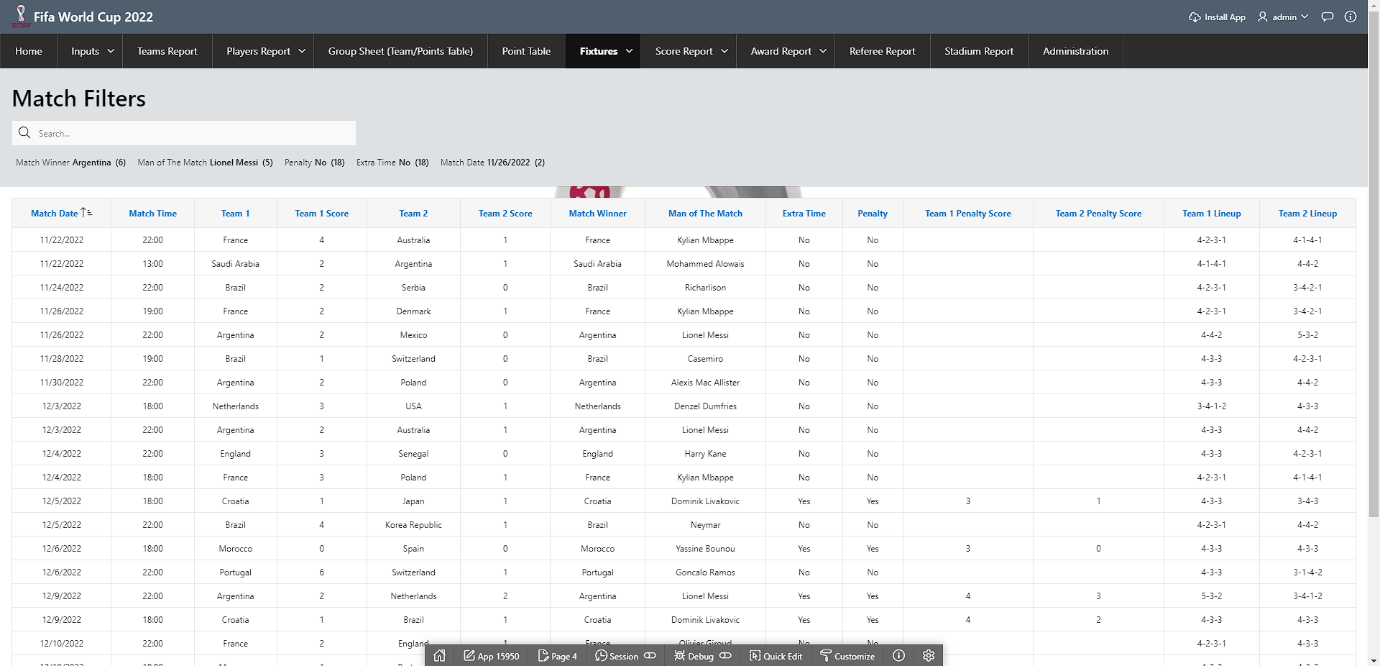

*figure 7.3. Parameterized Reports (Match Filters)*

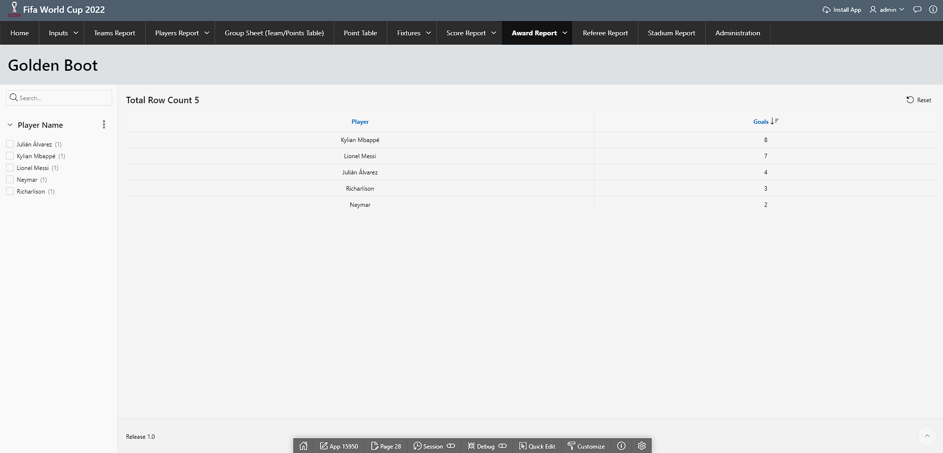

*figure 7.4. Parameterized Reports (Golden Boot)*

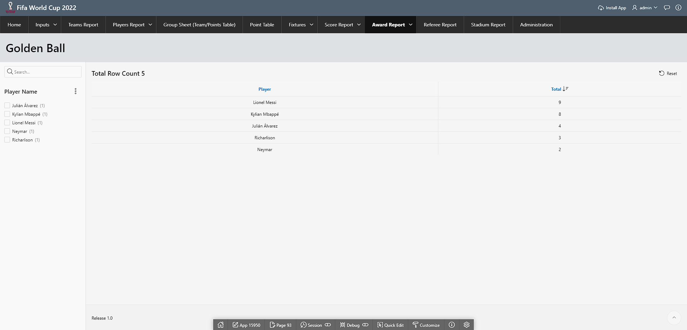

*figure 7.5. Parameterized Reports (Golden Ball)*

# Charts and Other Pages

| Page Number and Name | Chart description |
| --- | --- |
| Page 95: Players Performance | This bar chart shows sum of goals for each player |
| Page 96: Players Overall Performance | This bar chart shows sum of goals and assists for each player |



*figure 8.1. Chart (Players Performance)*



*figure 8.2. Chart (Players Overall Performance)*

# Authorization and User Role Assignment

**User Role Assignment**

| User name | Password | Role |
| --- | --- | --- |
| admin | admin | Admin |
| nisarga | nisarga | Admin |
| rudra | rudra | Reader |
| ashraful | ashraful | Reader |

**Page-wise Authorization Information**

| Page number and name | Authorization Level |
| --- | --- |
| P1: Home | Reader |
| P2: Inputs | Admin_Only |
| P71: Teams Report | Reader |
| P8: Players Report | Reader |
| P36: Players Information | Reader |
| P130: Group Sheet (Team/Points Table) | Reader |
| P10: Point Table | Reader |
| P98: Fixtures | Reader |
| P123: Match Information | Reader |
| P4: Match Filters | Reader |
| P27: Score Report | Reader |
| P95: Players Performance | Reader |
| P96: Players Overall Performance | Reader |
| P45: Award Report | Reader |
| P28: Golden Boot | Reader |
| P93: Golden Ball | Reader |
| P43: Referee Report | Reader |
| P48: Stadium Report | Reader |
| P34: Group Input | Admin_Only |
| P11: Team Input | Admin_Only |
| P12: Player Input | Admin_Only |
| P13: Stage Input | Admin_Only |
| P14: Stadium Input | Admin_Only |
| P15: Schedule Input | Admin_Only |
| P36: Referee Input | Admin_Only |
| P17: Lineups Input | Admin_Only |
| P18: Match Input | Admin_Only |
| P19: Award Input | Admin_Only |
| P20: Final Positions Input | Admin_Only |
| P21: Match Statistics Input | Admin_Only |
| P22: Points Table Input | Admin_Only |
| P40: Score Input | Admin_Only |
| P47: Match Referee Input | Admin_Only |
| P115: Administration | Admin_only |

# Concluding Remarks

We used the internet and class lectures to learn new features. We experimented with many features that had not been covered in class. We learnt new things through this project.